

July 2026



'I will survive...or flourish?'

Much has been made of the now defunct Bible Society report, the 'Quiet Revival' which suggested that we are experiencing, well, a church revival. The YouGov stats were faulty, and they have since apologised for this. Too late for everyone who thought that this might be true including senior figures, our bishops and theological educators. We're so desperate to see growth, rather than the decline we've experienced for so long, that any hint of good news is seized upon. Understandable.

Despite this, we are seeing really encouraging signs of people, young and old, returning to church. Is it a revival? I'm not so sure. Is it good news? Definitely!

Growth is something we all want, but is not in my view something to obsess about. Since the early 1900's, the church has been in decline and yet, we are still here. Reports of our imminent collapse have proven untrue, something I'm very grateful for. And yet, as a diocese, as a national church, turning back the tide of decline IS an obsession and one I think we need to get rid of.

For St Mary's, our growth is coming from members of the congregation going out and telling folk about what we do, about our worship and about how faith can change your life. I don't send people out with sandwich boards on their backs and we don't use any fancy evangelisation tools. We are ourselves. It seems to me that this approach, less dramatic when compared to new initiatives and hugely expensive 'resource churches' or 'plants' might be the way to sustained growth, not just in numbers, but in spirituality. Slowly and surely, this personal witness, kindness, honesty, faults and all, is what people are interested in.

So, the next time I'm invited to some new form of 'being church', when the next email arrives, I shall perhaps gently decline. Not because I'm not interested in new ideas, but because I trust that our growth, however slow, comes not from what we do, but from what God wants to do through us.

Phillipians 2: 13: 'For it is God who works in you to will and to act in order to fulfill his good purpose.'

Rev Nathan Jarvis

Church news

Our monthly Work Parties, tidying the Churchyard, continue on Saturday 4th July, last Month there were only three of us, with a bit of luck we’ll get better weather this time. We’ve uncovered what seems like dozens of graves where they’ve been hidden by the Rhododendrons over the years…remember to bring coffee and a snack, we start at around 10am.

We will be having our first monthly Bible Study on Monday 13th July at 6.30pm. Depending on numbers this may be at The Rectory or another venue, possibly the Village Hall, for more information speak to Austin.
A reminder that we will be having the next Fish & Chip Supper and Quiz Night on Friday 24th July at 7pm in the Village Hall - Arrival at 6.30pm. The last one, in April, was a great night out, with good food and great company! There is a list in the Church, to let us know you’ll be attending.

.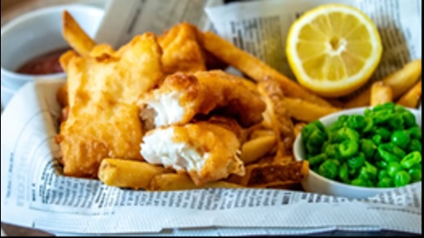

The “Blessing of the animals” service is on Sunday 19th July, I understand from Nathan that you can bring any animal with you (unless dangerous) from mice to Great Danes like Barry’s Delilah! Didn’t we have a pony last year? More information from Don.

We are still keen to move folk to standing order giving, just set up the standing order to our Church (covenants) Bank account: 30696439 sort code:20-53-77. If you need any help to move, Phil, Debs or Alan can help.

Diary dates
JULY
Sunday 5th July 9.45am – BCP– Nathan
Sunday 12th July 9.45am BCP Linda
Monday 13th July Bible Study 6.30pm Rectory
Tuesday 14th July 10.30am Coffee - De Trafford Arms, Alderley – All welcome
Saturday 18th July 10am Walking Group – Phil leading, local and easy!
Sunday 19th July 9.45 All Age Worship - Blessing of the Animals – Nathan & Don
Friday 24th July Fish & Chip supper 6.30 for 7pm Village Hall
Sunday 26th July 9.45am World Day of Prayer for older people– Nathan
August
Sunday 2nd August Common Worship Eucharist - 9.45am – Nathan

Remember, if you need to check what’s on at the Church, go to the website, what’s on/Rota or use this link: https://www.alderleychurch.co.uk/rota/

200 club winners:
1st Ronalda Dyas 2nd Juliana Maynard 3rd Rachel Mogg

