

April 2026

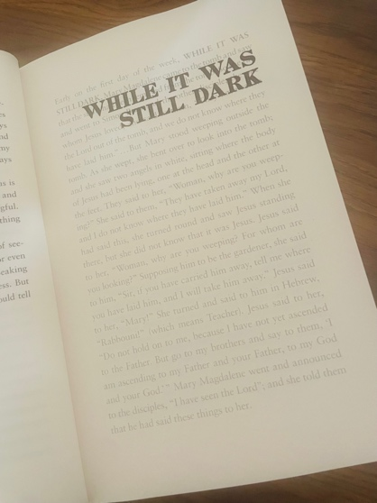

I'm reading a fantastic book at the moment. I didn't choose it particularly as a lenten book, but that is what it's turned into for me. I hesitate to recommend it as it's quite radical and contains some bad language, and yet, I also want you to experience it as it's been transformational as I've read it over the last week or so. It's called 'Cranky, beautiful faith' by Nadia Bolz-Weber. She's a Lutheran cleric from America, and she has a lot to say about life, the world and the role of faith. She was explaining how she came to God and to ministry after a turbulent early life, but it was when she recalled the Easter story that my mind froze. One sentence made me pause, breathe and gave me hope in what has felt like a hopeless few weeks.

While it was still dark

It struck me that the story of redemption and new life did not stop as night fell. Jesus, appearing to Mary, making Himself known before he has ascended, fills me with a sense of calm. The work of God was going on, unseen, not yet revealed to human eyes.

The world feels very dark at the moment. The illegal American/Israeli war, the immense suffering, the senseless acts of violence against innocent women and children fill us with horror and disgust. We find it hard to see any end. We feel it's almost impossible to see the light.

And yet, the dawn will come.

We may not see the presence of God in any of this, but even though it is dark, He is there.

We are drawing close to the most holy part of Lent as we get even closer to Easter. On Easter Saturday, we will gather in the dark, lighting the first fire. From one small spark, the church is illuminated and in turn, the world acknowledges that hope has come into the world yet again.

Nadia says this: 'the Christian faith is really about death and resurrection. It's about how God continues to reach into the graves we dig for ourselves and pull us out, giving us new life, in ways both dramatic and small.'

Life may seem dark, but light is coming. Hold on for the light.

Rev Nathan Jarvis

Church news

Normal service now resumes, we are back with a packed Easter of services as well as “fellowship, fun and fish and chips” on Friday 10th April. Stuart and Izzy are running the event, in the Hall, 6.30 for 7pm. As we need to organise the supper its reserved places only, sign up on the list in the Church or email: stmaryalderley@gmail.com.

Please note Maundy Thursday and Good Friday services at 6pm on each evening & this Mondays service (mindfulness with meditation) is at 7.30pm. Remember too that we have the Easter Egg hunt on Easter Sunday, immediately after the service, see how many you can find (age dependent!).

Lovely walk, last Saturday, with thirteen of us turning out for a ramble around Sandbach and countryside – let Will know if you’d like to join us or be added to the email list.

Don is planning to have monthly work parties on the first Saturday of the month, although due to a wedding in April, we’ll be starting THIS SATURDAY 29th March! Please come down to give us a hand – it’s great fun…remember to bring coffee and a snack, we start at around 10am.

Diary dates
Sunday 29th March Palm Sunday Eucharist, family friendly - 9.45am – Nathan
Monday 30th March – 7.30pm Mindfulness service with meditation – Nathan
Thursday 2nd April - 6pm Maundy Thursday Liturgy – Nathan
Friday 3rd April - 6pm The Good Friday Liturgy - Nathan
Sunday 5th April - 9.45am EASTER SUNDAY All age Eucharist with Easter Egg Hunt - Nathan
Friday 10th April Fellowship, fun and Fish & chips, Parish Hall 6.30 for 7pm
Sunday 12th April 9.45am Common worship - Nathan
Tuesday 14th April 10.30am Coffee - De Trafford Arms, Alderley – All welcome
Saturday 18th April – Walking group – see Will for details
Sunday 19th April - BCP 9.45am – Linda
Sunday 26th April 9.45am - Vocation Sunday Service - Nathan
MAY
Sunday 3rd May BCP 9.45am - Nathan

Remember, if you need to check what’s on at the Church, go to the website, what’s on/Rota or use this link: https://www.alderleychurch.co.uk/rota/

200 club winners:
FEB
- Malcolm Bell 2. Peter Bean 3. Juliana Maynard
MARCH
- David Mogg 2. Maureen Wooley 3. Margaret Worthington

