

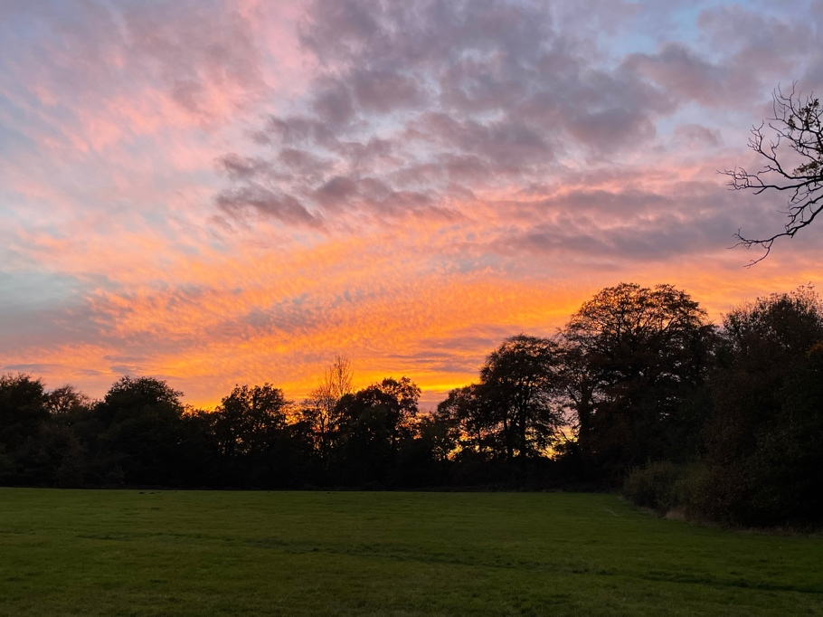

December 2025
'In peace I will lie down and sleep, for you alone Lord, make me dwell in safety.' Psalm 4:8
It sounds a bit odd for a clergyman to be speaking about peace and rest when we're about to begin one of our busiest seasons as we gear up to Christmas. Advent is full of all sorts of extra services and events and our course called 'Journeying together', and yet, stillness, rest and peace are going to be top of my priority list for me and for you.
I was looking out over what seemed like a barren garden the other day. It's been a year of trying to sort out the outside spaces at the Rectory, digging, getting rid of invasive weeds and preparing the ground for next year. It all looks a bit gloomy at the moment. But we can learn a lot from this seemingly fallow time as the earth rests and prepares for what is to come. Look closely, all may seem quiet and still on the surface, but lift a leaf or delve into the hedgerows around St Mary's and life goes on, life in all its abundance, albeit a bit chillier.
For me, Advent is a bit like this.
We call this season a penitential season, a time of contemplation, prayer and good works and yet we usually just plough on, driven by the desperate desire all around us to get to Christmas and get it over with. Lights are up, trees are in the shops and even decorations are half price in Waitrose! It's as if it's all over, and we missed it. Advent is about turning our backs on all of that, even for a short time each day to lie down and simply enjoy the feeling of security which is freely given to us through faith in Jesus, something we badly need as the world continues to fight and posture. This is a time to breathe in the beauty of our surroundings here in Alderley, to still our hearts and minds and to be in the moment rather than rushing into a season which has not even begun; Christmas is a month away.
My prayer is that we find moments, just moments in every day where we can truly feel peace, a time to appreciate the safety we enjoy living in this place of great beauty and security.
This Christmas (when it comes), we are introducing a new service called a 'Quiet Christmas Service by candlelight' on the 23rd of December at 6.00pm. It's a short service designed for parents and Grandparents who might want a break from wrapping paper and food preparation, a time to pause and rest before the 'big day', to feel truly Christmassy, touched by the peace which only Jesus can bring. Do come along. And so I pray for moments of peace and rest in what might be a busy time for you, time to pause, time for you and time for God.
'In peace I will lie down and sleep, for you alone Lord, make me dwell in safety.' Psalm 4:8
Rev Nathan Jarvis
Church news

So, it’s Christmas and you’ll see a packed calendar of services and events starting with the Advent Evensong on Sunday 30th November A few of special things to look out for:
- Nathan is running three Tuesday evening events on the 2nd, 9th and 16th December starting at 7pm in the Parish Hall, with mince pies and mulled wine to follow!
- Drinks at the Rectory, always a lovely event – 6pm on Sunday 21 December.
- Quiet Christmas Service 6pm Tuesday 23rd December, vital for stressed out Parents and Grandparents!

We are launching our Christmas Hamper Appeal (generously donated by Linda) which we are raffling off to raise funds for St Marys. As you are all probably aware, it’s the congregation who pay for the upkeep & ongoing expenses of our lovely Church, we get NO help from the Government, Diocese or anyone else. Tickets are £5 each, available online, choose 1, 2, 3 or 4 tickets using the link: https://givealittle.co/c/3qU03pDNnepkSFPwobVj4J) or buy them the old fashioned way in Church. Prizes are displayed in the back of the Church and Nathan will be drawing the prize on Christmas day!

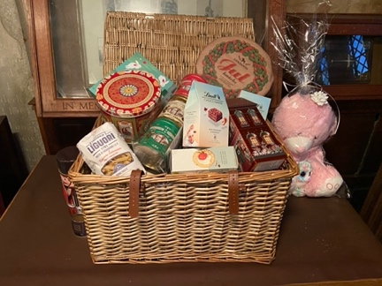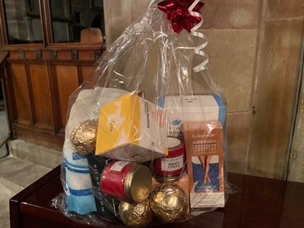

Diary dates
Sunday 30th November Eucharist 9.45am – Nathan
Sunday 30th November ADVENT Evensong by candlelight 6.00pm – Nathan
Tuesday 2nd December 7pm - Journeying – Reflections on Advent (1) - Village Hall
Saturday 6th December Village Hall Christmas Fair
Sunday December 7th ALL AGE SERVICE 9.45am – Nathan
Tuesday 9th December 10.30am Coffee - De Trafford Arms, Alderley – All welcome
Tuesday 9th December 7pm - Journeying – Reflections on Advent (2) - Village Hall
Sunday 14th December 9.30 BCP – Linda
Tuesday 16th December 7pm - Journeying – Reflections on Advent (3) - Village Hall
Saturday 20th December – Christmas walking group - Terry
Sunday 21st December All Age Eucharist 9.45am am – Nathan
Sunday 21st December Drinks at the Rectory 6pm
Monday 22nd December BCP 6pm 9 Lessons & 9 Carols - Nathan
Tuesday 23rd December 6pm Quiet Christmas service – Nathan
Wednesday 24th December 2.30pm Crib Service – Nathan
Wednesday 24th December 10.30pm Midnight Mass – Nathan
Thursday 25th December 9.45am Christmas Morning service – Nathan
Sunday 28th December BCP

Remember, if you need to check what’s on at the Church, go to the website, what’s on/Rota or use this link: https://www.alderleychurch.co.uk/rota/

200 club winners:
- Christopher Harrison 2. Lesley Marsh 3. Judy Sawles

