

October 2025
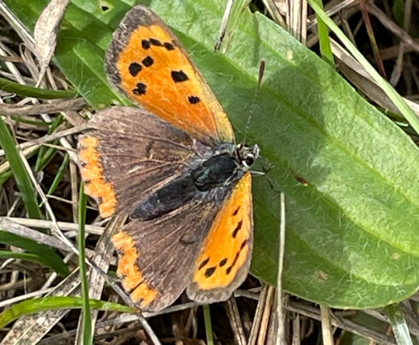
Glory in small things
Do you want a big life? Do you hold ambitions to be famous, a great businessman, or a TV star? Maybe you have a dream of being a politician and changing the world…
I used to think that success had to look ‘big’, had to be impressive in the eyes of the world, and maybe even in the eyes of the church. I wondered whether I was destined for greater things, until I came to a realisation; I am already living those ‘greater things’ by being happy in my life, my family and my ministry.
It was quite a revelation.
To be happy in the small things is both biblical and also really life-enhancing. All the self-help books on mental health site being satisfied and really appreciating and valuing the small things actually makes us happier. Tell this to a world constantly looking for the next best thing, especially young people comparing themselves to airbrushed and AI enhanced reality, something no human being can achieve. Saint Paul taught, “Do everything for the glory of God” (1 Corinthians 10:31). Making every small act a gift for God is like turning sand into gold.
Think about that for a moment.
All the small things we do, even the day-to-day things, can be done to the glory of God.
When I do my early morning walk around the church fields, I try to notice the small things, try to notice the sights, smells, sounds and sensations all around me. I enjoy ‘parking’ the concerns and worries of everyday life, even just for twenty minutes as I experience the joys of Alderley. What I noticed was that there were still lots of butterflies around, and frogs still hopping in the long grass and still lots of berries in the hedgerows, rosehips and blackberries for the birds and sloe berries for the Rector’s gin!
The place is alive, literally hopping with life. To see, is to appreciate.
To appreciate is to turn ones mind to God. To think on God, is to praise Him.
As we move into the season of mellow fruitfulness and as we prepare for harvest, for colder nights and crisp mornings, take a look at what’s around you. Before you know it, the little things become the big things, and for a moment, just a moment, the world is a better place as we praise God for the abundant life he has given us.
St. Thérèse of Lisieux advised, “Remember that nothing is small in the eyes of God. Do all that you do with love.” Achieve holiness through little ordinary things.
I’m quite happy being ordinary. Are you?
Rev Nathan Jarvis
.
Church news
Please make sure you check the diary below, as there are several changes to a busy schedule of services and times in October:
- Sunday 12th Oct morning service moves to 11am, as we have Harvest Lunch, NOW FULL – If you would like to donate raffle prizes, please bring on the day.
- There is no morning service on Sunday 26th Oct, as we have a Eucharist in the evening at 6pm.
- Sunday 2nd November – two services, we have morning service at the normal time, then at 6pm we have an All-Saints Service. This is one of our most popular and poignant services, at which we commemorate family, friends and loved ones who have passed away.
- Remembrance service on Sunday 9th, then moves to 11am

The Christian Aid Quiz night is on OCT 11th in the Scout Hut on Talbot Rd Alderley…at 7pm for 7.30, tickets are £15 per person to include a fish and chip supper. Fiona can organise tickets and give you much more info, but please let her know ASAP – bring your own drinks.

Great news on heating, its installed and ready to warm us up for the Winter! Whilst it has taken around two years and lots of paperwork to obtain the faculty, it was all worth it in the end. Last thing is to set up the HIVE system so we can organise the heating on an App, very modern!

If you would like to join up with Oasis as a prayer partner, contact Lisa at her email address: lisa.brown@oasisgorton.org

Diary dates
Sunday 5th October ALL AGE SERVICE 9.45am - Nathan
Sunday 12th October 11am Eucharist – Nathan NOTE CHANGE OF TIME
Sunday 12th October HOTPOT Harvest Lunch straight after the service
Tuesday 14th October10.30am Coffee at the De Trafford Arms, Alderley – All welcome
Saturday 18th October - Walking group led by Debra
Sunday 19th October 9.45am BCP – Linda
Saturday 25th October Dog Walkers Breakfast Wizard tea rooms 10am – led by Nathan
Sunday 26th October 6pm Evening Eucharist – Nathan NO MORNING SERVICE
Sunday 2nd November 9.45am BCP – Linda
Sunday 2nd November 6pm ALL SAINTS SERVICE - Nathan
Sunday 9th November Remembrance Service 11 am – Nathan

Remember, if you need to check what’s on at the Church, go to the website, what’s on/Rota or use this link: https://www.alderleychurch.co.uk/rota/

200 club winners:
- Elizabeth Wareham 2. Lesley Kershaw 3. Fiona Ablett

