

November 2026

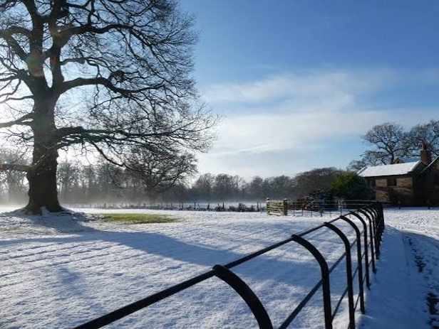

What’s your favourite film?

Perhaps it's too hard to choose, so maybe think of several......
My brother tells me that I have rather odd film tastes. I love subtitled films, in French, Welsh and Swedish, but I also like classic, more mainstream films. Along side the arty, I also like classics from my childhood such as Gremlins (scared the life out of me!), Back to the Future (doesn't seem as exciting as you get older) and E.T. (still makes me cry...).
My all-time favourite film is Chocolat. If you've not seen it or read the book, go out and get a copy right now, or watch it on YouTube. It'll change your life. I promise!

It's about a young single mother who, after years of moving from place to place, rents a very run down bakery in a conservative, deeply religious small French village. The place is dominated by the local Catholic church and it's deeply religious Mayor. It's Lent; a period of deep reflection, penitence and abstinence, and frivolity and joy is frowned upon. She keeps it a secret, folk trying to see what she is creating in the shop behind the blocked out windows. Holy Week arrives and the brown paper is taken down to reveal a chocolatier; a glorious Easter scene, a wonderful, mouth-watering group of rabbits, chicks and chocolate eggs filling the window. The village is aghast, so tempting is this display of abundance and 'naughtiness'. The mayor is furious. He tries to stop people shopping there, attributing the role of moral guardian to himself.

On Holy Saturday, after resisting temptation for so long, he is found in the middle of the window display, covered in chocolate, asleep, having eaten half the Easter Scene. I shan't spoil it by telling you all the details, but what follows is a wonderful story of acceptance; of the stranger, of difference, of those who are outcast. Suspicion and control are replaced with sheer joy, love and new life.

I'm sharing this story as we approach another penitential season.

Advent is a time for deep reflection and examination of ourselves and indeed our church. We are entering a period of 'quiet before the storm', particularly if you are a clergy-person. It is a time of personal preparation and a time for stillness before the season of celebration. As with the film Chocolat (I'll be asking if you've read it, so get cracking!), we move from preparation and contemplation to full on celebration and revelry, but, as with the obscured windows of that shop, we do so not fully knowing what we might see, experience or learn. As tempting as it is to rush head-long into the festivities, we need this time of stillness and preparation.

And so, let us begin to prepare our hearts and our minds being fully alert, setting our hope on the grace which will be brought to us, when Jesus Christ is revealed at his coming. (1Peter 1:13)

Rev Nathan Jarvis

Church news
As we run up to Christmas, I’ve listed both the full November and December calendar. Please note, many services, particularly as we get into December are at later times in the evening (when the Church is at its most spectacular). On that note, Michael and the flower team are appealing for donations to the flower fund in order to make Advent and Christmas special at St Marys. A donation box (with gift aid envelopes) is on the memorial table at the back of the Church.
Monday 2nd November –at 7pm we have our ALL-SOULS SERVICE. This is one of our most popular and poignant services, at which we commemorate family, friends and loved ones who have passed away.

Our monthly Work Parties, tidying the churchyard, are finished now until Spring 2027, big thanks to everyone who helped! Big Thankyou from Oasis & Lesley M for all the help provided by St Marys, throughout the year!

We are still keen to move folk to standing order giving, just set up the standing order to our Church (covenants) Bank account: 30696439 sort code:20-53-77 “PCC St Marys Alderley”.

Diary dates
November
Sunday 1st November 9.45am Eucharist – Nathan
Sunday 2nd November 7pm ALL SOULS SERVICE - Nathan
Sunday 8th November 10.30am Remembrance Service - Nathan
Monday 9th November Bible Study 6.30pm Rectory
Tuesday 10th November 10.30am Coffee - De Trafford Arms, Alderley – All welcome
Sunday 15th November 9.45am Eucharist – Nathan
Saturday 21st November 10am Walking Group
Sunday 22nd November 9.45am BCP– Linda
Sunday 29th November 6pm Advent Sunday evening service with Deanery Choir - Nathan
December
Sunday 6th December 9.45am Eucharist – Nathan
Tuesday 8th December 10.30am Coffee - De Trafford Arms, Alderley – All welcome
Sunday 13th December 9.45 BCP - Linda
Monday 14th December Bible Study 6.30pm Rectory
Saturday 19th December 10am Walking Group
Sunday 20th December 9.45pm Eucharist – Nathan
Sunday 20th December 6pm RECTORS CHRISTMAS DRINKS at the Rectory
Monday 21st December 6pm Quiet service by candlelight - Nathan
Wednesday 23rd December 6pm 9 lessons & 9 Carols - Nathan
Thursday 24th December 2.30pm Crib Service - Nathan
Thursday 24th December 10.30pm Midnight Mass - Nathan
Friday 25th December 9.45am Christmas Day – Nathan
Sunday 27th December 9.45am Eucharist - Nathan

Remember, if you need to check what’s on at the Church, go to the website, what’s on/Rota or use this link: https://www.alderleychurch.co.uk/rota/

200 club winners:
1st Sarah Jane Wilkinson 2nd Joyce Davis 3rd Will Ablett

